**CLASS CODE FOR LOGGER.H :-**

#ifndef LOGGER_H

#define LOGGER_H

#include <iostream>

#include <fstream>

#include <string>

#include <mutex>

class Logger {

private:

std::ofstream log_file;

std::mutex log_mutex;

public:

Logger(const std::string &file_name) {

log_file.open(file_name, std::ios::app);

if (!log_file.is_open()) {

std::cerr << "Failed to open log file: " << file_name << std::endl;

}

}

~Logger() {

if (log_file.is_open()) {

log_file.close();

}

}

void log(const std::string &message) {

std::lock_guard<std::mutex> guard(log_mutex);

std::cout << message << std::endl;

if (log_file.is_open()) {

log_file << message << std::endl;

}

}

};

#endif

**SERVER CODE WITH LOGGER.H :-**

#include <iostream>

#include <fstream>

#include <cstring>

#include <sys/socket.h>

#include <netinet/in.h>

#include <unistd.h>

#include <thread>

#include "logger.h" // Include the logger

Logger logger("server_log.txt"); // Create a logger instance for the server

void handle_client(int client_socket) {

char buffer[1024];

// Log client connection

logger.log("Client connected");

// Receive file info

ssize_t bytes_received = recv(client_socket, buffer, sizeof(buffer) - 1, 0);

if (bytes_received <= 0) {

logger.log("Error receiving file info");

close(client_socket);

return;

}

buffer[bytes_received] = '\0';

std::string file_info(buffer);

size_t comma_pos = file_info.find(',');

std::string filename = file_info.substr(0, comma_pos);

size_t filesize = std::stoul(file_info.substr(comma_pos + 1));

// Open file to write received data

std::ofstream output_file(filename, std::ios::binary);

if (!output_file) {

logger.log("Error opening file");

close(client_socket);

return;

}

// Receive file data

while (filesize > 0) {

ssize_t bytes_received = recv(client_socket, buffer, sizeof(buffer), 0);

if (bytes_received <= 0) {

logger.log("Error receiving file data");

break;

}

output_file.write(buffer, bytes_received);

filesize -= bytes_received;

}

output_file.close();

logger.log("Received file: " + filename);

close(client_socket);

}

int main() {

int server_fd = socket(AF_INET, SOCK_STREAM, 0);

if (server_fd < 0) {

logger.log("Socket creation error");

return 1;

}

sockaddr_in server_addr {};

server_addr.sin_family = AF_INET;

server_addr.sin_addr.s_addr = INADDR_ANY;

server_addr.sin_port = htons(65432);

if (bind(server_fd, (struct sockaddr*)&server_addr, sizeof(server_addr)) < 0) {

logger.log("Bind failed");

close(server_fd);

return 1;

}

if (listen(server_fd, 5) < 0) {

logger.log("Listen failed");

close(server_fd);

return 1;

}

logger.log("Server listening on port 65432");

while (true) {

sockaddr_in client_addr {};

socklen_t client_addr_len = sizeof(client_addr);

int client_socket = accept(server_fd, (struct sockaddr*)&client_addr, &client_addr_len);

if (client_socket < 0) {

logger.log("Accept failed");

continue;

}

std::thread(handle_client, client_socket).detach();

}

close(server_fd);

return 0;

}

**OUTPUT FOR SERVER CODE WITH LOGGER.H :-**

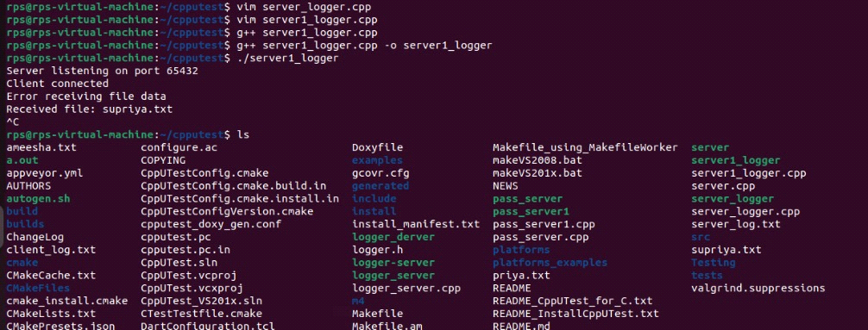

**CLIENT CODE WITH LOGGER.H :-**

#include <iostream>

#include <fstream>

#include <cstring>

#include <sys/socket.h>

#include <netinet/in.h>

#include <unistd.h>

#include "logger.h" // Include the logger

Logger logger("client_log.txt"); // Create a logger instance for the client

void send_file(const std::string& filename, const std::string& server_ip, uint16_t server_port) {

int client_socket = socket(AF_INET, SOCK_STREAM, 0);

if (client_socket < 0) {

logger.log("Socket creation error");

return;

}

sockaddr_in server_addr {};

server_addr.sin_family = AF_INET;

server_addr.sin_port = htons(server_port);

if (inet_pton(AF_INET, server_ip.c_str(), &server_addr.sin_addr) <= 0) {

logger.log("Invalid address/ Address not supported");

close(client_socket);

return;

}

if (connect(client_socket, (struct sockaddr*)&server_addr, sizeof(server_addr)) < 0) {

logger.log("Connection failed");

close(client_socket);

return;

}

std::ifstream input_file(filename, std::ios::binary | std::ios::ate);

if (!input_file) {

logger.log("Error opening file");

close(client_socket);

return;

}

std::streamsize filesize = input_file.tellg();

input_file.seekg(0, std::ios::beg);

std::string file_info = filename + "," + std::to_string(filesize);

send(client_socket, file_info.c_str(), file_info.size(), 0);

char buffer[1024];

while (input_file.read(buffer, sizeof(buffer)) || input_file.gcount() > 0) {

send(client_socket, buffer, input_file.gcount(), 0);

}

input_file.close();

logger.log("File sent successfully");

close(client_socket);

}

int main() {

std::string filename;

std::cout << "Enter the filename to send: ";

std::cin >> filename;

send_file(filename, "127.0.0.1", 65432);

return 0;

}

**OUTPUT FOR CLIENT WITH LOGGER.H :-**

